Atalasoft
Document Region Template Demo
User Guide

Atalasoft Support
8/13/2013

Table of Contents
Document Region Template Creator 2
Getting Started: Opening the Application 2
Opening a Template Document 2
Applying Document Clean Up 3
Adding Regions to your Template Document 5
Navigating Pages 7
Saving your Document Region Template 7
Document Region Template Reader 9
Getting Started: Opening the Reader Application 9
Opening a Document 9
Selecting an Alternate Template Path 10
Choosing the Template for your Document 10
Applying Document Clean Up 11
Navigating Pages 12
Processing Individual Defined Regions 13
Processing All Defined Document Regions 13

Document Region Template Creator

Getting Started: Opening the Application
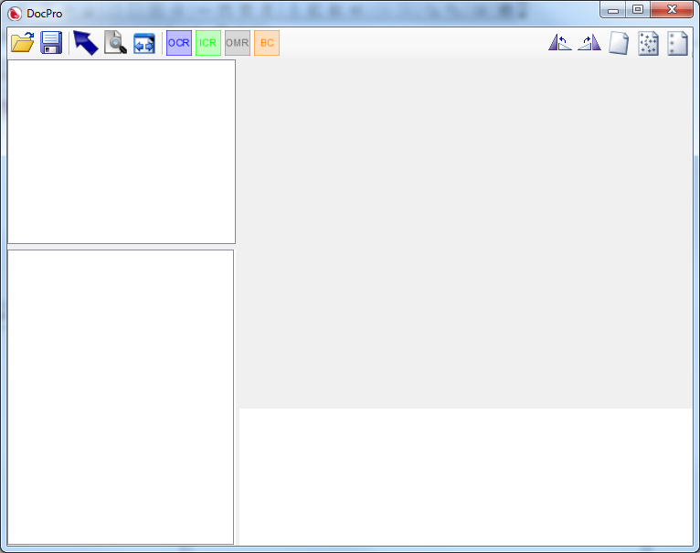
First things first, let’s open the template creator. It should be named DocumentRegions.exe
It will look like this image to the right.

Opening a Template Document
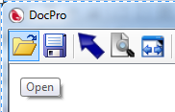
Select “Open” from the top menu.

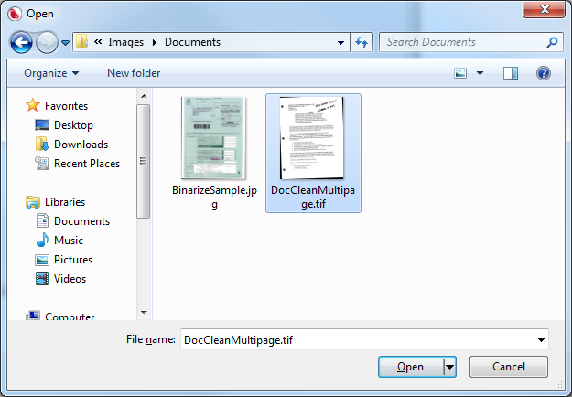

Choose your template document. This document is the template you want to base all of your scanning regions against.
Note: This application will work with both single page formats (.jpg) and multipage formats (.tiff/.pdf)
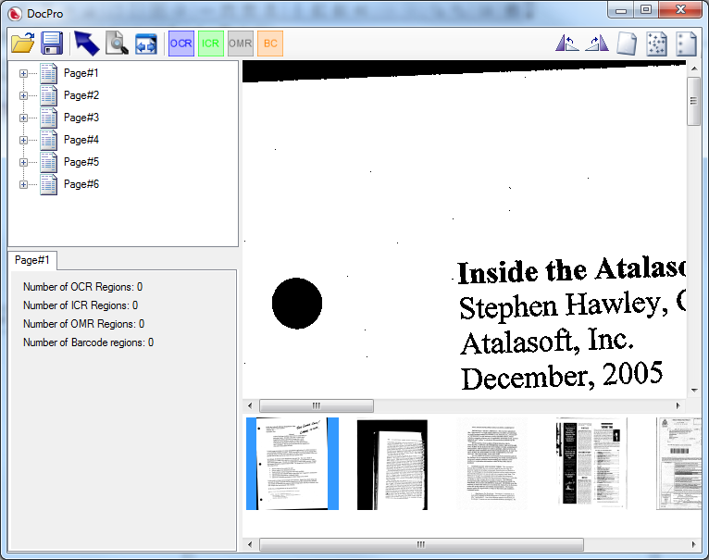
Once you’ve selected your template document, it will load in to the viewer.
Note that each page has both a thumbnail at the bottom (for easy navigation) and an entry in the tab view on the left (to keep track of created regions).

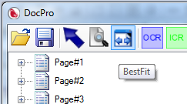

You may want to best fit your document so the entire page is viewable in the reader at one time.
Just click the “BestFit” button.

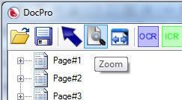
You can always zoom in later if you need to.

Applying Document Clean Up
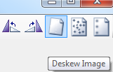
Before we start this, note it is very important that any clean up you apply to your template document be applied to the images you process later. Especially rotate and deskew!
Deskew is very useful for any document coming in from a scanner. It will attempt to see if the document came in skewed and automatically correct it.

Before deskew
After deskew
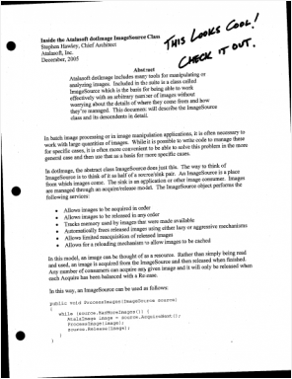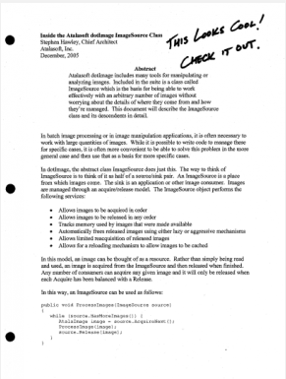
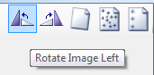
Rotating the image is quite straight-forward, just pick the relevant direction to rotate the image.
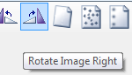
Again, make sure that any modifications you make to your template document are also made to the documents you will be running the region reader against as well.

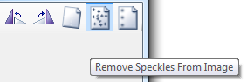
Removing speckles from a scanned document can help improve the accuracy of the reader when applied to your scanned document. You will only benefit from using it in the reader however.

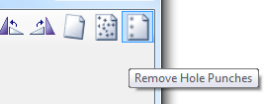
Remove hole punches attempts to automatically remove any hole punches present in the scanned document. Again, you will only benefit from using it in the reader.

Adding Regions to your Template Document

There are four types of regions you can define using this application.
- OCR Regions will be run through the text recognition engine
- ICR Regions have been removed as the GlyphReaderEngine does not support them
- OMR Regions are used to process checkboxes and bubble fields
- BC Regions will be run through the barcode engine
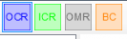
To add a region, simply choose the region type from the top menu.
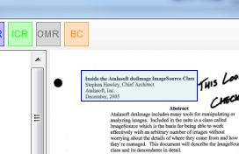
Then click and drag on the document where you want the region created.

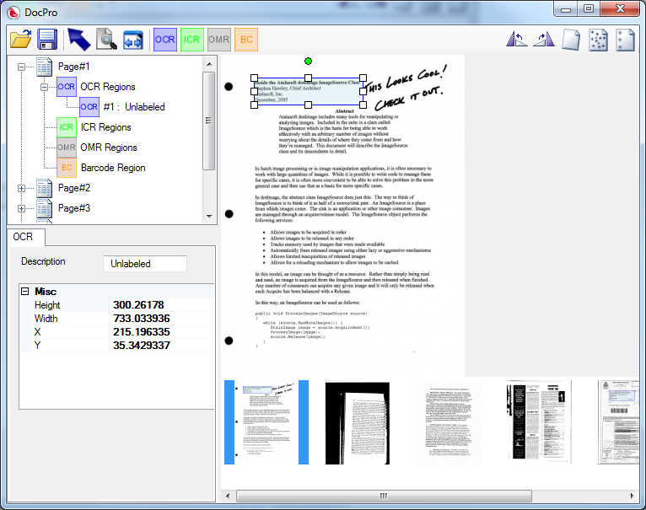
It will create an entry in the left hand tree and show the properties for your newly created region in the bottom-left view as well.

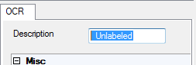
You should change the Description to a meaningful description of the region.

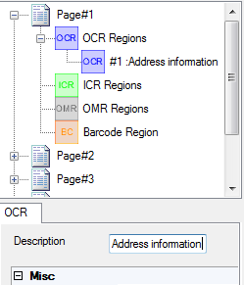

Changing the Description will automatically update the tree when changed.

Simply repeat this process for all the relevant regions of this page of your document. Then repeat for each page within your document.

Navigating Pages
You can get to each page within your template document using either the tree view on the left or the thumbnails at the bottom.
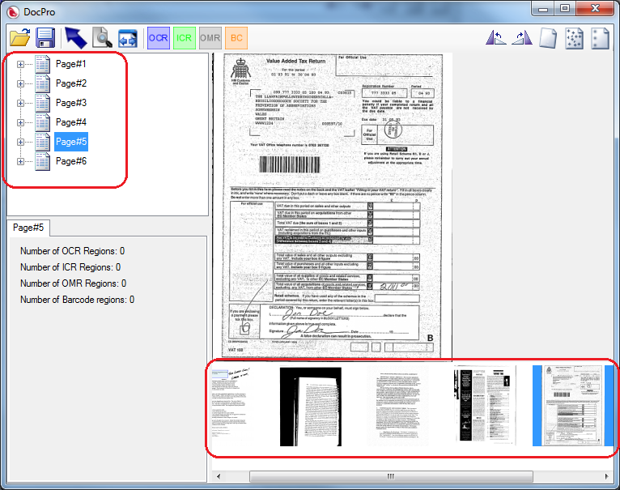

Saving your Document Region Template
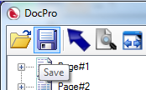
Once you have added all the regions for your document, click “Save” from the top menu.

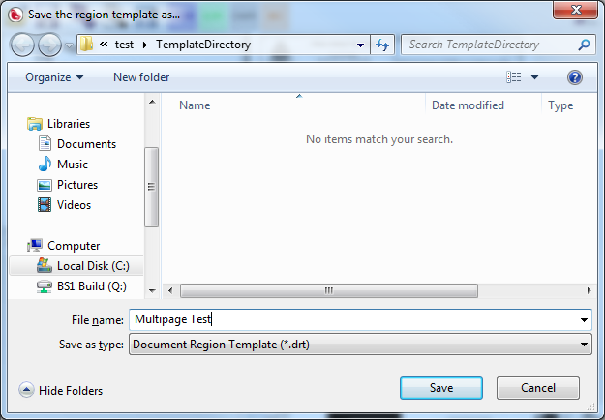
Choose a meaningful name for your template.
Note: by default the templates are saved at c:\test\TemplateDirectory and the Region Reader application may not read them if they are moved.

Document Region Template Reader

Getting Started: Opening the Reader Application
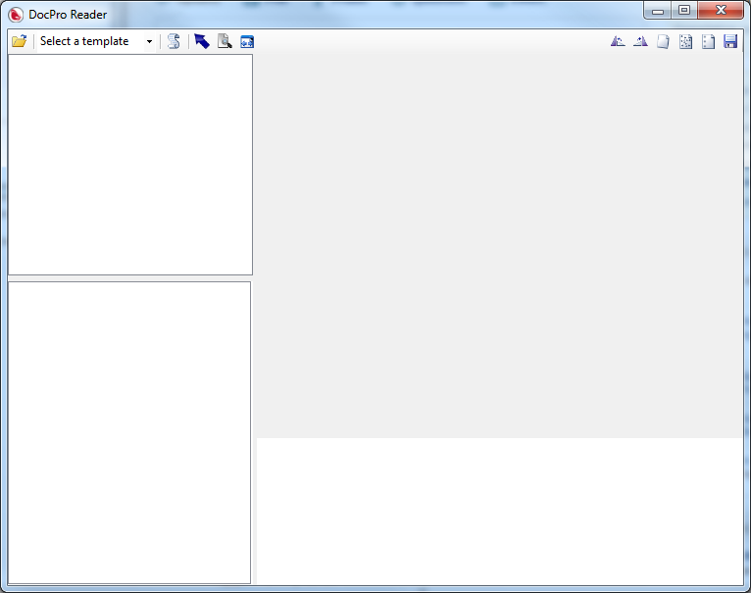
First things first, let’s open the template reader. It should be named DocumentRegionsReader.exe
It will look like this image to the right.
Please Note: If you have not created the Document Region Templates yet (created with the first application) you will not be able to use the reader yet.
Technical Note: If you get errors starting the application regarding RecoStar take a look at the knowledge base article located at: http://www.atalasoft.com/KB/article.aspx?id=10321

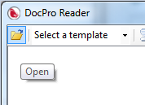
Opening a Document
Before you do anything else, you need to open a document to run the reader against. Select the “Open” icon.

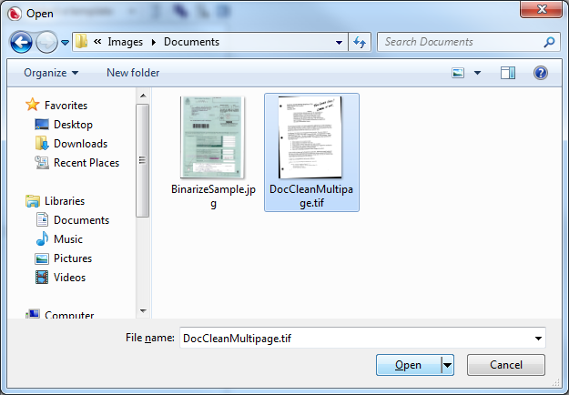

Then choose the document you want to run your template against.
This application can open both single page formats (.jpg) and multipage formats (.tiff/.pdf)

Selecting an Alternate Template Path
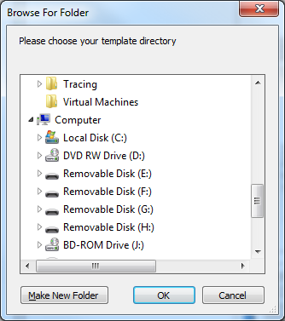
If the default template path of c:\test\TemplateDirectory doesn’t exist the reader will automatically prompt you for the path where your templates are saved.
Navigate to where your templates are saved, and hit OK.

Choosing the Template for your Document
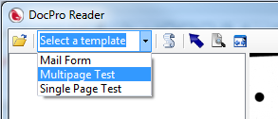
Pick the template from the dropdown.
It will list all of the templates in your template directory. Simply choose the appropriate one for your document.

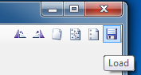
Alternatively, you can click the “Load” icon and navigate to the template for your loaded document.
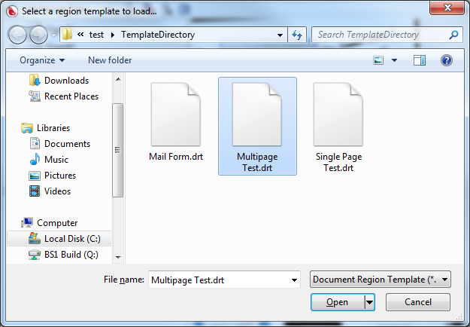

Simply click “Open” once you’ve selected the correct template for your document.

Applying Document Clean Up
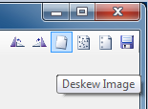
Note: It is very important that you apply the same clean up to the document you are reading as you applied to the document you made the template from. Especially rotate and deskew!

Deskew is very useful for any document coming in from a scanner. It will attempt to see if the document came in skewed and automatically correct it. Just make sure you used it on your template as well.

Before deskew
After deskew


Rotating the image is quite straight-forward, just pick the relevant direction to rotate the image.

Again, make sure that these modifications match what you made to your template document.


Removing speckles from a scanned document can help improve the accuracy of the recognition engines.



Remove hole punches attempts to automatically remove any hole punches present in the scanned document.

Navigating Pages
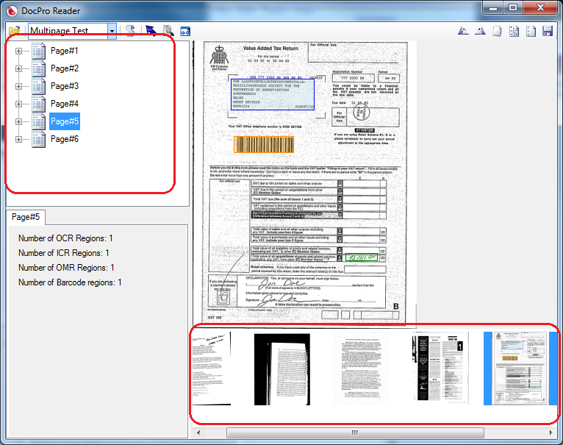

You can get to each page within your template document using either the tree view on the left or the thumbnails at the bottom.

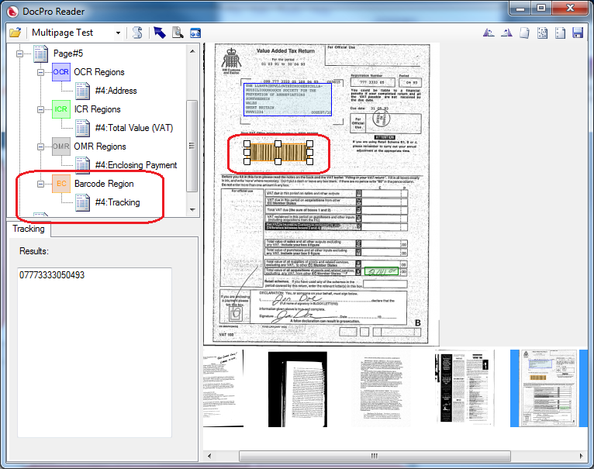
Processing Individual Defined Regions

Testing individual regions is simple, just navigate to the relevant page and click either the region node in the tree view or directly on the region on the document.
The results show up in the results box in the lower left.

Processing All Defined Document Regions
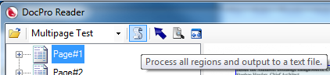
Simply click the “Process all regions and output to a text file.” button.

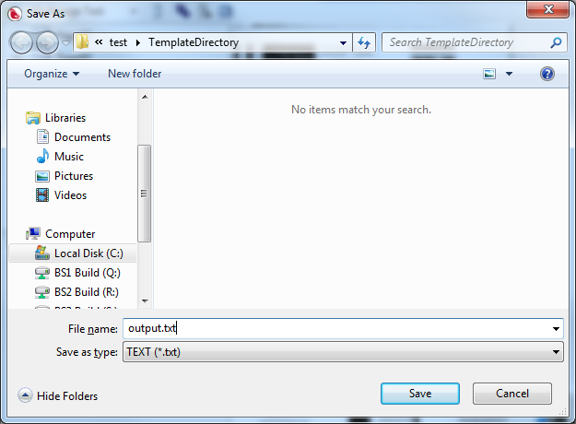
It will prompt you where to save the processed text.
Just choose where you want the results saved and click “Save”

